**Micronics Technology H89 ESP32 Interface Status**

**Darrell Pelan**

**16 Apr 2022**

Contents

Design Status 1

Hardware Design 2

Ports 2

Status 2

Commands Under Development 3

Notes 3

Software 4

Startup messages: 4

Webpage Processing Messages: 5

H89 Interface Messages: 5

Webpage Interface 6

# Design Status

The breadboard is currently undergoing software design/ testing. The hardware design is stable. It has a input, output, and status register. The ESP32 uses three interrupts: writes to Port 7E, write to 7C, and a read from 7C. The H-89 determines if the ESP32 is ready for data or data is available by reading port FD.

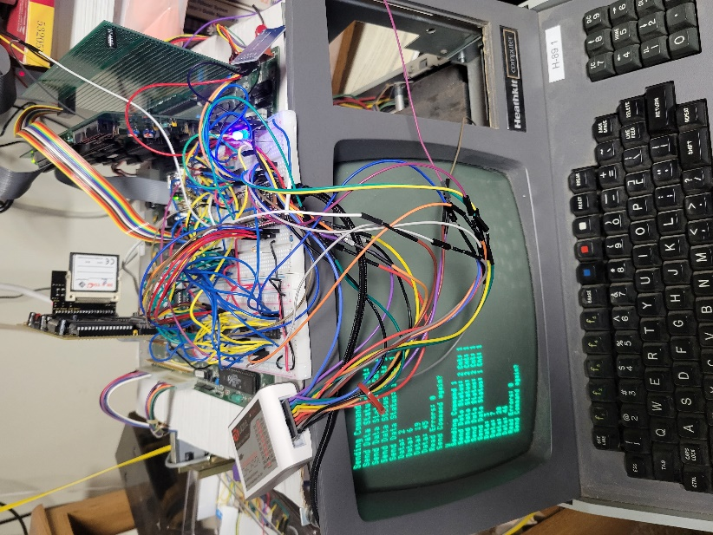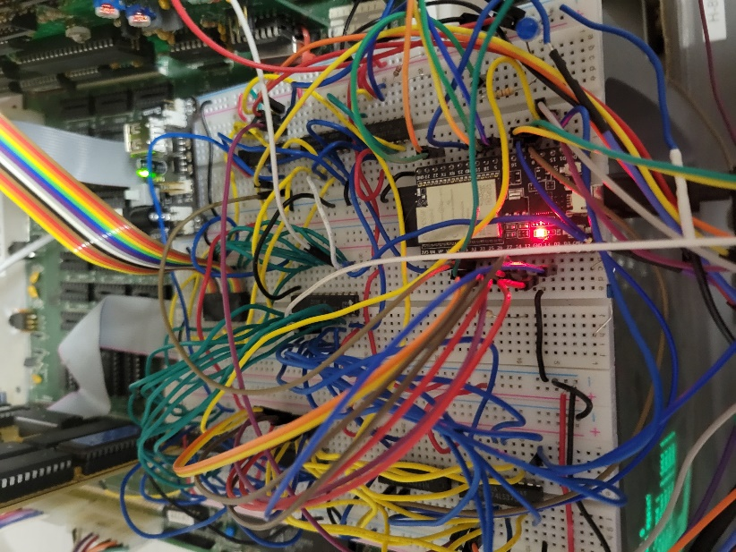

# Hardware Design

## Ports

The interface is designed to use the three of the H-17 port addresses

|  |  |  |
| --- | --- | --- |
| **H-89 Addr** | **Read Port Function** | **Write Port Function** |
| FC | Read Data | Write Data |
| FD | Read Status | N/A |
| FE | N/A | Tells ESP32 command is coming |

## Status

The ESP32 sends status on two bits using port FD.

|  |  |  |  |  |
| --- | --- | --- | --- | --- |
|  | **Bits** | |  |  |
| **ESP32 Status** | **1** | **0** |  | **Decimal** |
| ESP Ready for Command | 0 | 0 |  | 0 |
| H89 Read Data Ok | 0 | 1 |  | 1 |
| H89 Write Data OK | 1 | 0 |  | 2 |
| ESP Busy | 1 | 1 |  | 3 |

## Commands Under Development

**Command byte definitions:**

|  |  |
| --- | --- |
| **Cmd1** | Drive # | Head # |
| **Cmd2** | Track | Sector |
| **Cmd3** | # Sectors to read/Write |

## Notes

* I’m still working on how to integrate this board with CP/M. The select disk image command is designed to support having the ESP32 act like a disk system. In order for this to be bootable, The H-89 will need a modified MTR-90 EPROM and a default bootable disk image.

# Software

## Startup messages:

Micronics Technology H89 ESP32 interface

This program comes with ABSOLUTELY NO WARRANTY; for details type `L' at the menu.

This is free software, and you are welcome to redistribute it

under certain conditions

WiFi Configuration ...

Loading Configuration ...

Checking Data

Please enter ssid (15 char or less): xxx

Please enter wifi password (15 char or less): xxx

Please enter web user id (15 char or less): admin

Please enter web password (15 char or less): admin

perf ssid: pelan

Connecting to Wifi:

.....

Network Configuration:

----------------------

SSID: pelan

Wifi Status: 3

Wifi Strength: -31 dBm

MAC: 98:F4:AB:76:D0:68

IP: 192.168.1.44

Subnet: 255.255.255.0

Gateway: 192.168.1.1

DNS 1: 192.168.1.1

DNS 2: 0.0.0.0

DNS 3: 0.0.0.0

Configuring Webserver ...

Elegant OTA Initiated

HTTP Server Has started Sucessfully

To access OTA Update, type

192.168.1.44/update

[E][sd_diskio.cpp:123] sdSelectCard(): Select Failed

Hi! I am H89-ESP32, Version 3.0 C

Status 0

Heap: Free 227468, Min: 225792, Size: 352236, Alloc: 113792

Menu

v: Prints version

b: Reboots system

r: Resets counters

s: SD card test

c: Clears NVM

m: Prints menu

## Webpage Processing Messages:

Client:192.168.1.29 / Auth: Failed

Client:192.168.1.29 / Auth: Failed

Client:192.168.1.29 / Auth: Failed

is authenticated via username and password

Client:192.168.1.29 / Auth: Success

Client:192.168.1.29 /favicon.ico

is authenticated via username and password

Client:192.168.1.29 /listfiles Auth: Success

Listing files stored on SD

## H89 Interface Messages:

(Currently there is one command that send four bytes to the ESP32. The ESP sends back the same four bytes plus one.)

Interrupt 7E count = 1

Buffer Last 4, Buffer Ptr 0

Cmd Byte 1

Cmd Byte 5

Cmd Byte 18

Cmd Byte 44

Sent 2

Sent 6

Sent 19

Sent 45

Data Out errors: 82618

Interrupt 7C count = 4

## Webpage Interface

The network ssid and password are stored in NVM. If it doesn’t exist, the ESP32 asks for the information, including the user id and password, over the USB interface. You can use the menu to clear NVM.

